**Meditating on the Bible**

**Joshua 1:8 NIV. *Keep this Book of the Law always on your lips; meditate on it day and night, so that you may be careful to do everything written in it. Then you will be prosperous and successful.***

**Psalm 1:2-3 NIV. *…but whose delight is in the law of the LORD, and who meditates on his law day and night. That person is like a tree planted by streams of water, which yields its fruit in season and whose leaf does not wither- whatever they do prospers.***

I spoke on Sunday (22-Jun-2025) about the importance of biblical meditation and how it can transform a Christian’s life and relationship with God. My spiritual ‘hero’ George Muller practised this discipline daily and obtained huge benefits from it in his relationship to the Lord and in his prayer life. ***“For my heart being nourished by the truth, being brought into experimental fellowship with God, I speak to my Father, and to my Friend about the things that He has brought before me in His precious Word”.*** Wouldn’t it be great if we were able to have the same testimony! Well, we can…

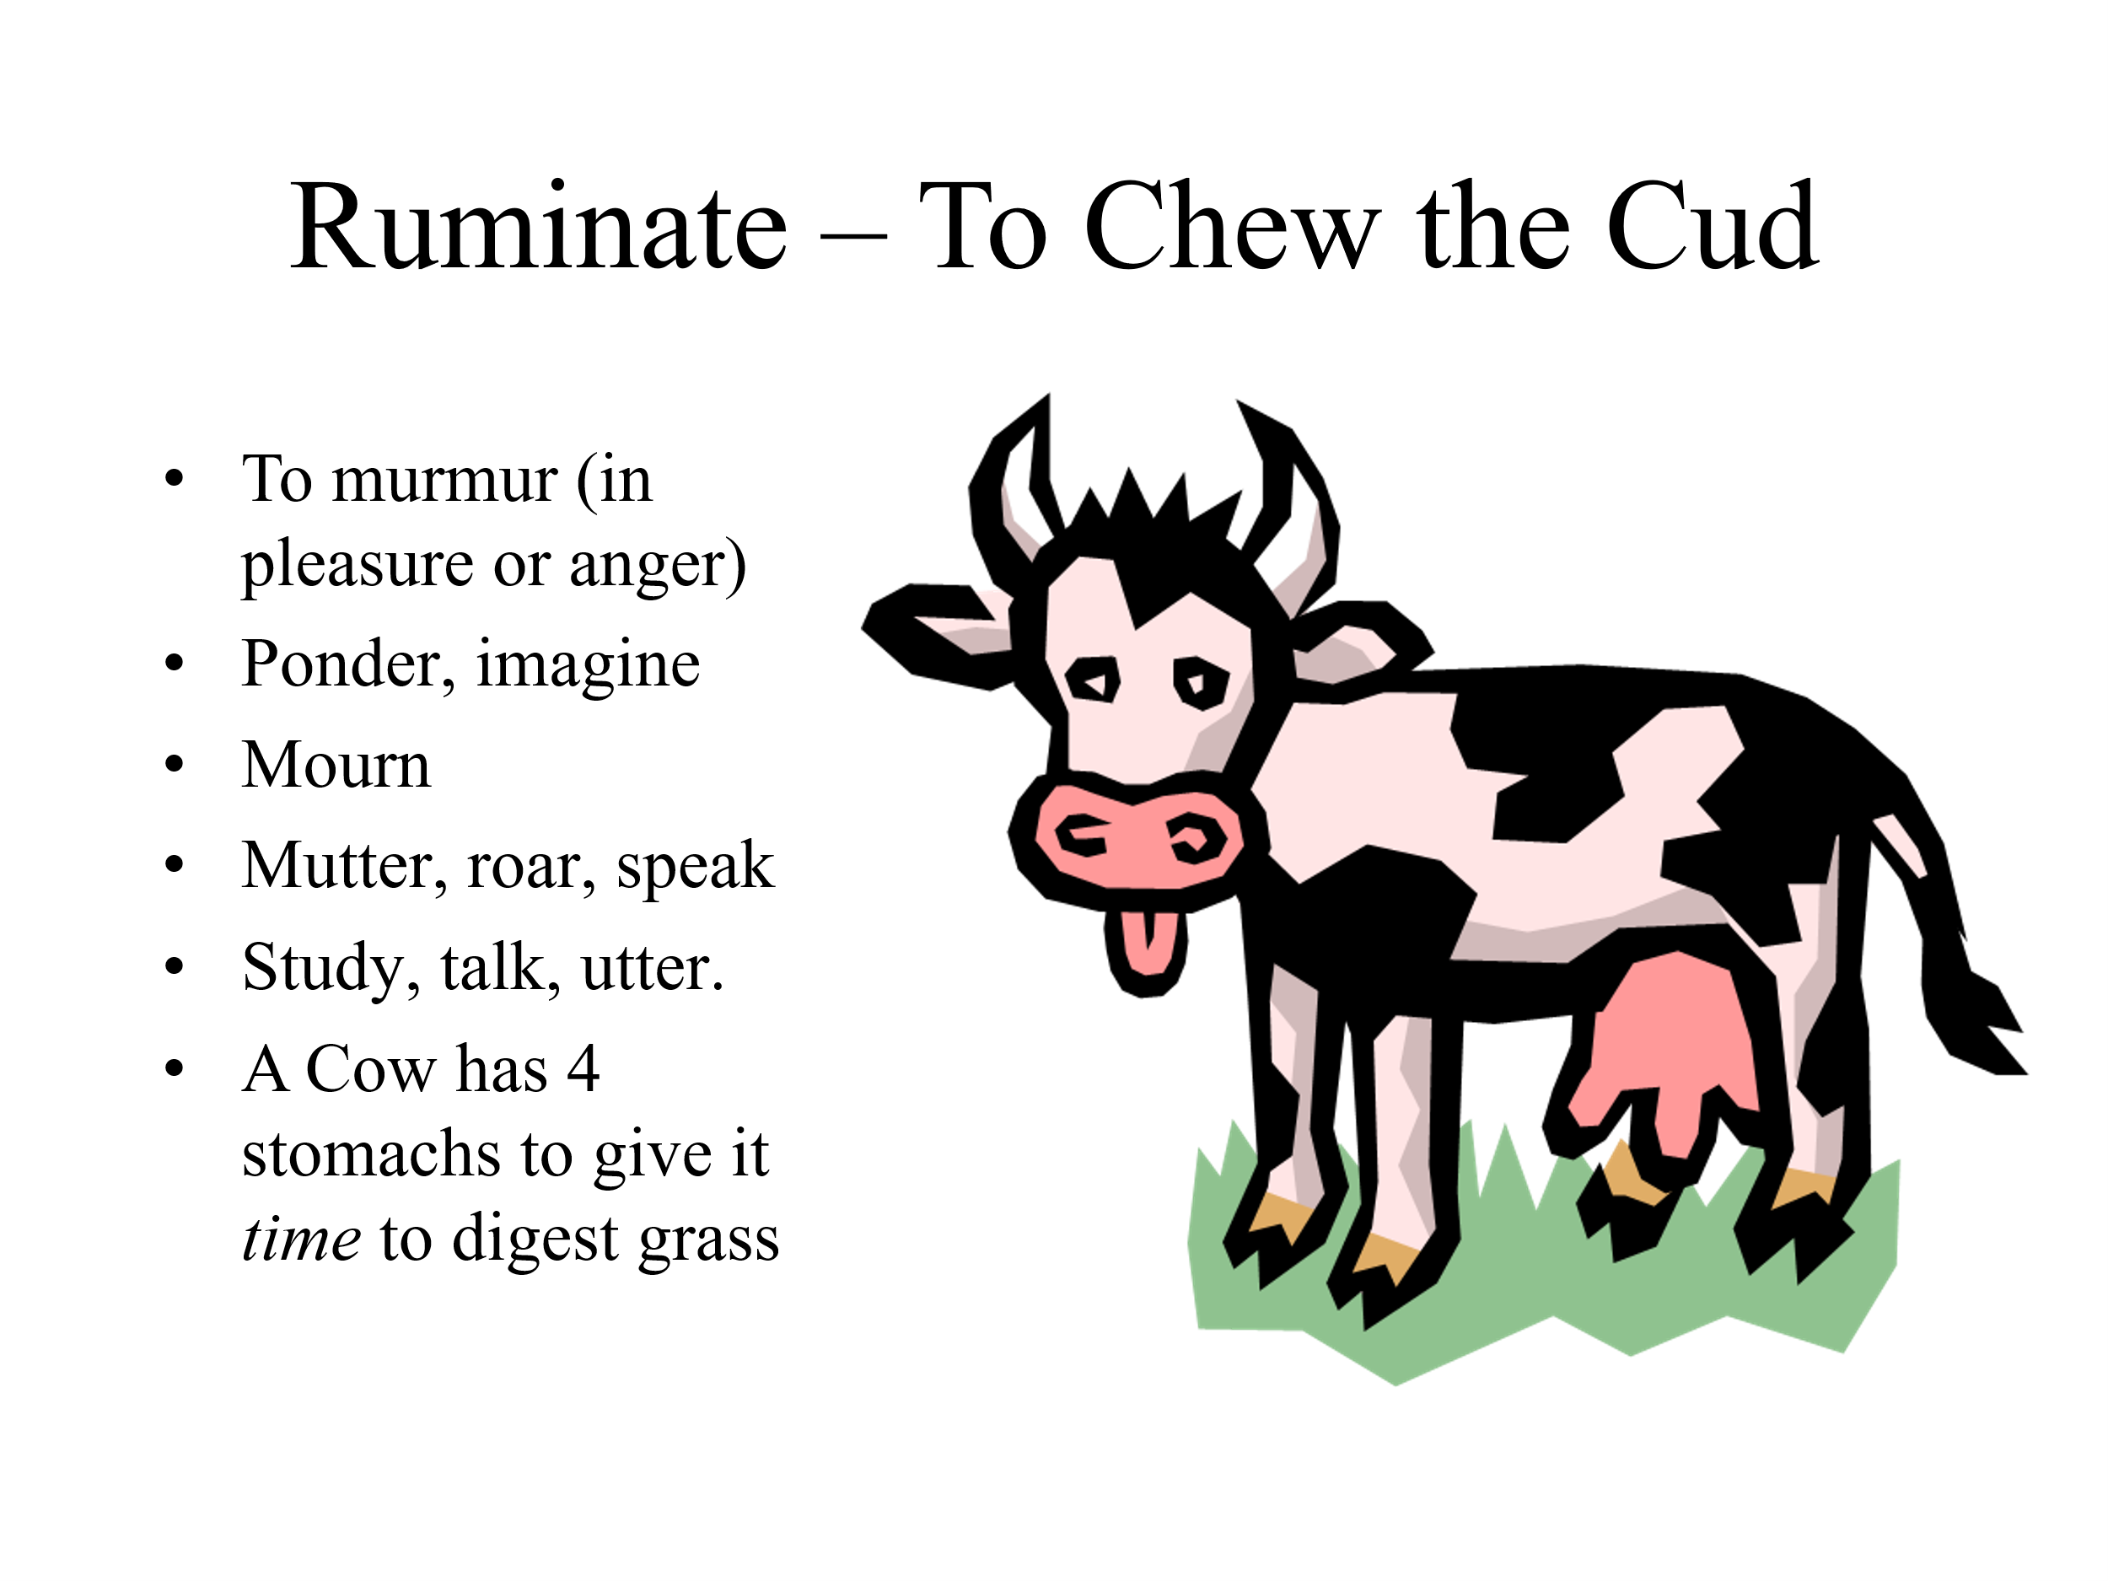

The term ‘Meditate’ is a word that is rather like ‘Ruminate’ – which is to ponder in your mind. The illustration of a cow chewing the cud is a good one: cows derive goodness from eating grass by their unique system of digestion. We can obtain goodness from the bible by ‘ruminating’ on small portions of it daily, helped by the Holy Spirit.

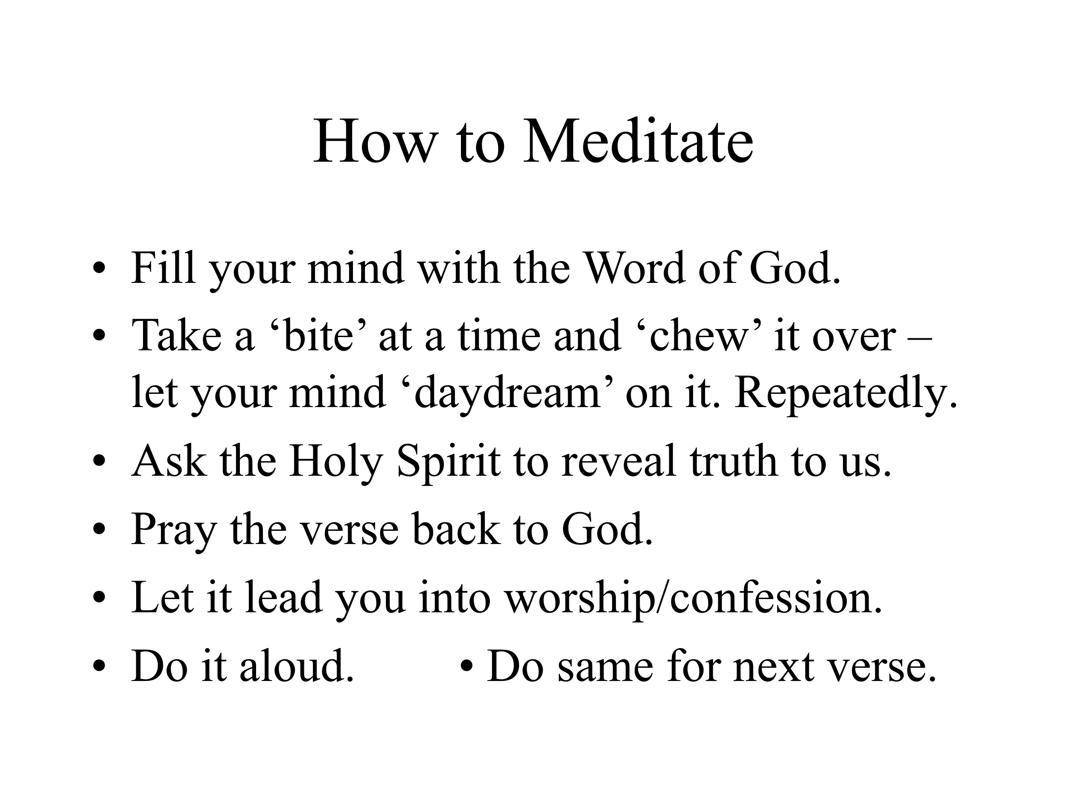

How can we combine this meditation with the daily readings from ‘The Bible In One Year’ that are so valuable to us in giving us an overview of the scriptures? We really need *both* disciplines.

I suggest that as you read through your daily readings, you ask the Holy Spirit to give you a couple of verses that you can memorise and then ‘take away’ with you for the remainder of the day, to recall from memory and ‘chew over’ as meditation.

In this way, you will get the benefits of *breadth* (reading the bible) and *depth* (meditating on some key verses) each day of your life.